Problem 12 – Factorial number system

Given an integer , compute 1+2+…+n and express the sum in the factorial number system.

In the factorial number system, an unsigned integer m is expressed as
where each d_{i} is an integer satisfying and except for m = 0.

For example,
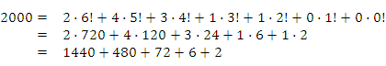
Input:
Each line of input contains an integer n 0. End of input is indicated by -1.

Output:
Output should contain K lines if there are K integer as input. Each line contains the coefficients of the factorial number system representation. The coefficients are separated by a single space and followed by no trailing spaces.
For example, the factorial number representation of the number 2000 would be expressed as 2 4 3 1 1 0 0.

Sample Input:
654321
12345678
-1

Sample Output from Sample Input:
1 7 1 5 4 3 1 1 1 0
3 4 0 1 3 4 3 1 0 0 0

All inputs are from stdin and outputs to stdout.

